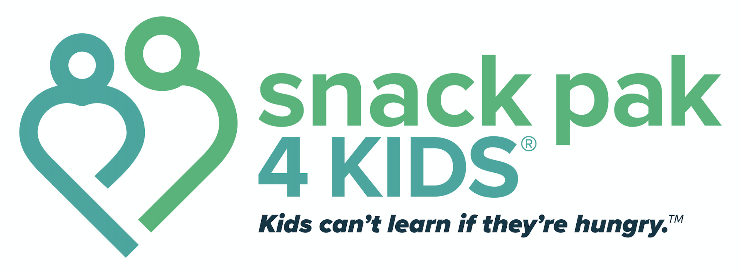

Snack Pak 4 Kids®—Referral Form (2021-2022)

Child’s Name:
Age: Grade: Class

Behavior that demonstrated Food Insecurity (Referral MUST include at least one item in this category)
□ Rushing food lines
□ Extreme hunger on Monday morning
□ Eating all of the food served
□ Lingering around for or asking for seconds
□ Comments about not having enough food at home
□ Other _____________________________________________________________________

Check any other factors that apply to this child:
Physical Appearance
□ Extreme thinness
□ Puffy, swollen skin
□ Chronically dry cracked lips
□ Chronically dry itchy eyes
□ Brittle, spoon-shaped nails
□ Other ______________________________________________________

School Performance
□ Excessive absences and/or tardiness
□ Repetition of a grade
□ Chronic sickness
□ Short attention span/inability to concentrate
□ Chronic behavior that leads to disciplinary action
(hyperactive, aggressive, irritable, anxious, withdrawn, distressed, passive/aggressive)
□ Other _________________________________________________________

Home Environment
□ Often cooks own meal, or have another sibling who does
□ Moves frequently
□ Often spends the night away from home (primary residence)
□ Loss of income
□ Family crisis
□ Other _______________________________________________________

If this child needs to receive extra food, please explain why:

Name/title of person referring the student:

Date of referral: Date approved:

Approved by:

