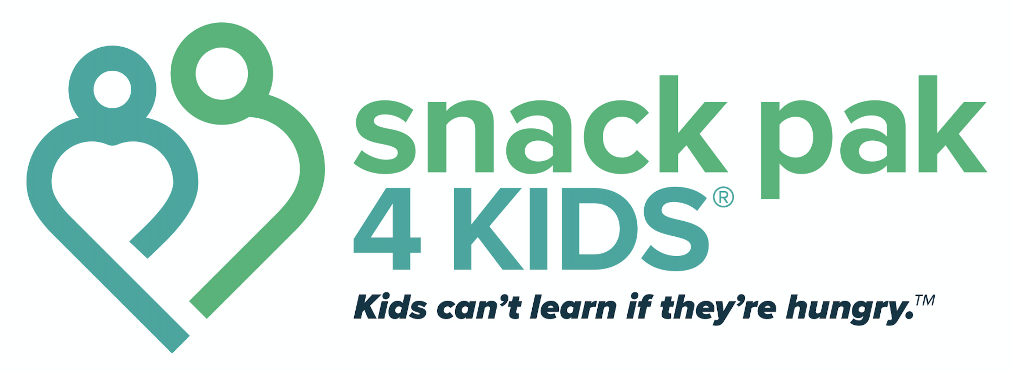

IS YOUR STUDENT HUNGRY?

Do they…
Rush food lines?
Have extreme hunger on Monday mornings?
Eat all their food?
Ask for seconds?
Eat others’ food?
Tell you they are hungry?
Are they…
Extremely thin or obese?
Do they exhibit…
Puffy or swollen skin?
Chronically dry/cracked lips?
Chronically dry/itchy eyes?
Hyperactivity, irritability, or are they withdrawn or aggressive?
Having problems getting along with others?
Excessively sick or absent from school?
If these signs occur on a regular and consistent basis, please contact
____________________________________________
Your School’s Snack Pak 4 Kids® Site Coordinator

