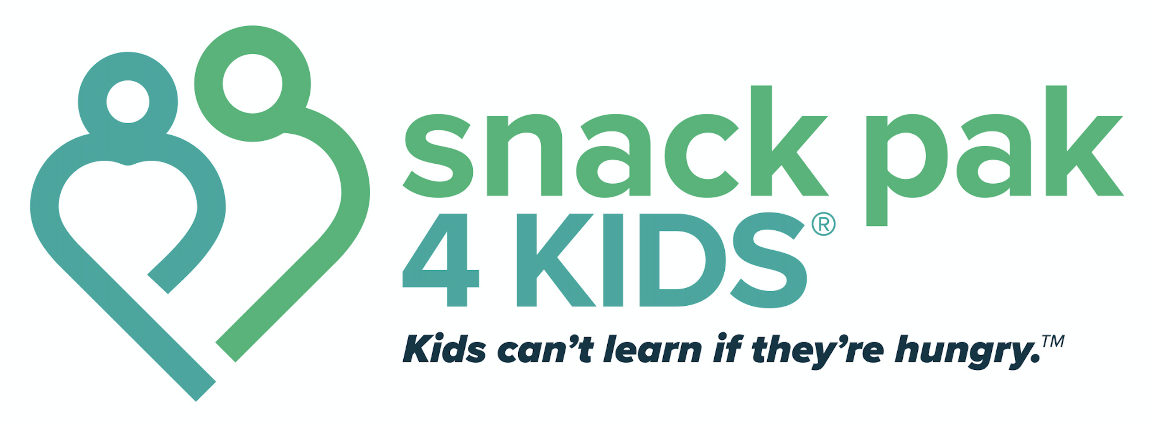

**School Coordinator Tasks and Responsibilities**

* ***Identify operation procedures for your specific site***
  + Where will you store the food? *Please leave the food in the Snack Pak totes.*
  + How will the students receive their Snack Pak in a discrete manner? Placing them discretely in backpacks or lockers is preferred. Distribution should only be done on Friday (or the last school day of the week.)
  + Bags should not be placed in a central area where students must retrieve them.   
    Students should never be singled out and called to an office or classroom to retrieve their bag.
  + Who will distribute should you be absent on a Friday? What is your backup plan for bad weather?
* ***Present Snack Pak 4 Kids® to all faculty and staff at your site*** 
  + Explain chronic hunger signs/symptoms and referral process. We suggest you have a meeting with the entire staff at the beginning of each school year, and reference the documents regarding chronic hunger (lounge flyer and Identifying Hungry Children).
  + All school forms can be found via our website at https://sp4k.org/resources/.
  + If you need assistance with presenting this to your staff, contact Becky at [becky@sp4k.org](mailto:becky@sp4k.org) or 806-626-9012.
  + **Let your faculty/staff members know that identification of students in need of Snack Pak is a team effort. *They can add/remove a student at any time.* The relationship between the student and the teacher is the best way to identify a need.**
* ***Place blank Child Referral forms in a convenient location for faculty/staff.*    
  Do NOT send forms home with every child.**
* ***Begin receiving child referrals from faculty/staff***
  + Place completed and approved referrals in a binder. ***\*Ask the nurse or child about any food allergies.***
* ***Send home notification letters/parent partnership forms to parents of referred children.   
  DO NOT SEND THE FORM TO ALL PARENTS.***
  + Snack Pak 4 Kids® requests you get permission from elementary school parents, but make sure to ***follow your school procedures and policies***. All permission forms remain in the possession of the school district. The partnership form is primarily to identify other children in the home, bring attention to the potential for allergens and open a line of communication between teacher and parent.
* ***Meet with referred children individually to explain Snack Pak 4 Kids****®*
  + “Backpack Buddies” or another creative name can be used when talking to the referred children about the program.
* ***Distribute bags to children on Friday.***
* ***Coordinate annual survey efforts with students in May and ensure they are returned to SP4K***
  + This is crucial. It helps us to know if we’re on the right track with the snacks we’re offering and the process in which we deliver them. It also helps to make sure we’re serving the right kids.