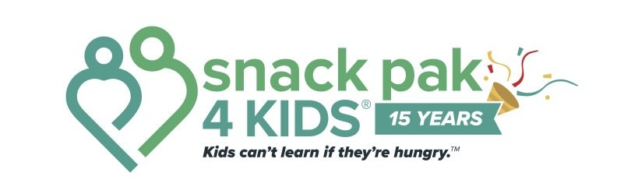

Snack Pak 4 Kids® School Coordinator Responsibilities

1. Establish Your School's Process
- Store food in the blue or green Snack Pak totes they are delivered in.
- Determine how bags will be distributed discreetly (backpacks or lockers are preferred).
- Distribute bags only on Friday (or the last school day of the week).
- Never require students to pick up bags from a central location or call them out publicly.
- Identify a backup person for Fridays and create a plan for bad weather or absences.
- This is Your School’s program – use it wisely and make it work for your students and staff.

2. Educate Your Staff
- Introduce Snack Pak 4 Kids® to faculty and staff at the beginning of the school year.
This is a student and educator resource – not a way for all students to get free snacks.
- Review signs of chronic hunger and the student referral process.
- Emphasize that identifying students in need is a team effort—teachers and staff may refer or remove students at any time if they see abuse.
- Program resources and forms are available at sp4k.org/resources.

3. Manage Student Referrals
- DO NOT SEND THE PARENT PARTNERSHIP FORM HOME TO ALL STUDENTS. The form should be sent only to families of referred students—do not send it school-wide.
- Make Referral Forms available. Review completed referrals and keep them in a secure place.
- ALLERGENS: Snack Pak 4 Kids is NOT a nut-free facility. Bags often contain nut or other allergen items. The signed Partnership Form is vital so parents and the school are aware of potential interactions.
- Follow your district's policies regarding parent permission.
- Keep all signed forms at the school. These do not get shared with Snack Pak 4 Kids.

4. Weekly Responsibilities
- Email your total number of bags needed by Monday afternoon each week. Send to Becky at becky@sp4k.org. Changes can be made, but a number on Monday helps us get things ready.
- Empty totes should be available for volunteer pickup when new totes are delivered.
- Please educate front office staff about Snack Pak delivery. Welcoming the driver, holding the door, and saying hello go a long way. Our drivers should leave totes near the entrance and never have to enter the building far enough that they need to sign in.
- Distribute Snack Paks discreetly on Friday.

5. Annual Survey (spring)
Coordinate the annual student and educator online survey. Survey results help improve the program, measure impact, educate donors, and ensure we are serving the students who need us most. It is VITAL to our program’s sustainability that each school participates in the survey.

