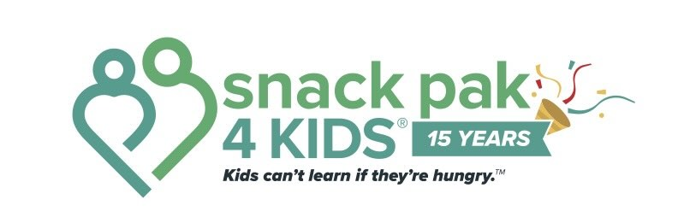

Snack Pak 4 Kids® Weekend Food Program 2026–2027 School Year
Dear Parent/Guardian,
(Name of School Here) is partnering with Snack Pak 4 Kids®, a nonprofit organization whose mission is to end weekend hunger. We know that for some families, weekends can be the hardest time to keep enough food on the table. Our goal is to help ensure students return to school on Monday ready to learn and thrive.
Research suggests that adequate nutrition has a positive link for your child’s learning capabilities. If your student could benefit from extra weekend food, we invite your child to participate in the Snack Pak 4 Kids program.
While there is no cost to your family, this is not intended to simply be a free-snack-program. It is a resource for your family and our educators to benefit your child’s food needs during the days he/she is not at school.
Each Friday (or the last school day of the week), your child will discreetly receive a bag of shelf-stable, child-friendly food at no cost to your family. Bags are placed privately in your child's backpack or locker whenever possible to protect each student's dignity and privacy.
Please complete and return the form below to your school's office. All information will be kept confidential.
Thank you for allowing us to serve your family.
Sincerely,
__________________________________
School Principal

Snack Pak 4 Kids® Partnership Agreement
Student Name:
School: Grade/Teacher:
*List any food allergies:
*Food allergens may be present in the Snack Pak bags. Please check all food items before consumption.*
Other children in the household (optional):
I understand that it is my responsibility to inspect all food items before my child consumes them. I acknowledge that food allergens may be present and release Snack Pak 4 Kids®, (School Name), and (School District) from liability for any allergic reaction or claim arising from the food provided.
Parent/Guardian Signature: Date:
Printed Name:
Participants are not discriminated against because of race, color, national origin, sex, age, or disability.

